CURRICULUM VITAE
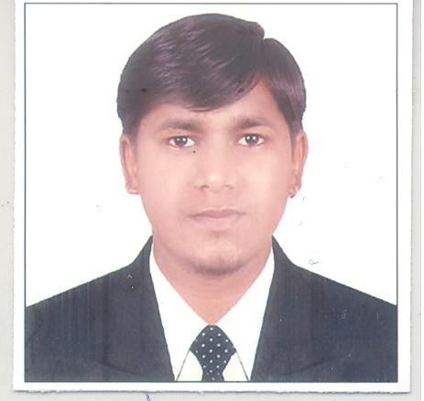 | Name  Email  Phone  Res. No  DOB  Specialization In  Address | :  :  :  :  :  :  :  : | Jitendra G. varma  Jitendravarma099@gmail.com  +91 9979301089  +91 8485947970  08/11/1991  Lean Six Sigma /Marketing Research/ISO  10/11, Desai colony,  Vishal Nagar main Road, Tarsali,  Baroda – 390009

CAREER OBJECTIVE:
To be professionally involved in whatever I have learned, realizing that the organizational objectives have to be achieved. It will be my prime priority to help the organization progress by leaps and bounds by utilizing my communication skills, interpersonal skills, analytical & problem solving skills and strong work ethic.
PERSONAL STRENGTHS:
- Handle work with patience.
- Easily mingle with people
- Honest toward my work and job
- Good Interpretation Power

EDUCATIONAL QUALIFICATION:
Completed Post Graduation in stream of MASTER IN QUALITY AND PRODUCTIVITY MANAGEMENT (M.Q.P.M) (Equivalent to M.Sc. Statistics) from Sardar Patel University, Vallabh Vidhya Nagar, Anand.
Examination |  | Month/ Year of  Passing | Board / University | Percentage (%)
S.S.C. |  | March 2007 | G. S. E. B. | 64.00
H.S.C. |  | March 2009 | G. S. H. S. E. B. | 68.71
B.Com. |  | March 2012 | Maharaja Sayajirao University of Baroda | 46.67
MQPM | Ist Sem | Nov-2013 | Sardar Patel University, V.V.Nagar | 72.77
MQPM | IInd Sem | April-2014 | Sardar Patel University, V.V.Nagar | 74.77
MQPM | IIIrd Sem | Nov-2014 | Sardar Patel University, V.V.Nagar | 75.24
MQPM | Iv^{th} Sem | May-2015 | Sardar Patel University, V.V.Nagar | 79.54

PROJECT WORK (DURING MQPM):
- 5 S (Sort, Set in Order, Shine, Standardized, Sustain) :
Project Title : Implementation of 5S
Name of Company : Nodule Cast
Location : Makarpura, GIDC
Implementation : Implementation of Sort, Set in Order, Shine and Standardized
Key achievements : Increase Work Efficiency, Hygienic Work Environment,
Increasing Productivity, Reduce Lead Time, Awareness about Safety.
- 7 QC Tools:
Description of tools : (Pareto Chart, Check sheet, Histogram, Scatter Diagram,
Control Chart, Cause & Effect Diagram, Brainstorming/
Affinity Diagram)
Project Title : To reduce rework and rejection in assembly department by
Implementing 7 Quality Control tools
Name of Company : Shivam Sundaram Engitech Pvt.Ldt.
Location : Makarpura, GIDC
Implementation : Implementation of Brainstorming, Check Sheet, Pareto Chart,
Cause and Effect Diagram, Control Chart ($\overline{X}$-R Chart).
Key achievements : Reduced reworks in assembly department by identifying the
root causes of technical fault.
- Marketing Research :
Project Title : Behaviour of customer while purchasing cloth
Location : Baroda, Anand, Khambhat, & Dahod.
Analysis : Factor analysis

- Six Sigma Project :
Project Title : Reduce Rejection of LABYRINTHRING-0830 by Using Six Sigma DMAIC Methodology.
Name of Company : Sujay Engineering
Location : Makarpura GIDC
Implementation : Statistical tool, DOE, ANOVA, Supplier Evolution, Sigma level calculation, C&E diagram, C&E matrix, FMEA, etc.
Key Achievement : By implementing DMAIC Methodology, Reduce rejection
Up to 12 unit and benefit generated of Rs. 1,64,211.

AREAS OF EXPERTISE:

- Network Analysis (CPM/PERT) / Optimization Techniques
- Regression Analysis, factor analysis, Data analysis, Interpretation of data
- Design of Experiment
- ANOVA
- Hypothesis Testing
- SQL, TQM, HRM,
FUNCTIONAL AREA:

- Quality Controller/ Assurance
- Production/ Operation Department
- Human Resource Department
- Data analysis/ interpretation on basis statistical tools
- Documentary work
- Marketing Research Department
IT/ SOFTWARE SKILLS:

- Having good knowledge of operation of programs like Microsoft Word, Microsoft
PowerPoint, Microsoft Excel, Microsoft Publisher, Microsoft Internet Explorer.
- Oracle 10g [SQL (Structure Query Language)]
- S.P.S.S 15 (statistical package for social science)
- Minitab 14, 16 (Statistical Software)
MANAGERIAL SKILLS:

- Problem solving & decision making skill
- Planning & time management
- Deal with Top And Bottom Management

OTHER ACHIVEMENT:

- I have published my Research on one the marketing Research topic.
- I have attempt UGC sponsored National Conference on “Latest Development in Basic and Applied Science’. (Poster Presentation) at M.B. Patel science College.
- I have got Medal (Sharp Shooter) during six sigma Black Belt training from BMGI.

WORK EXPERIENCE:
- I have been working with Shankar Packaging Limited as Process Controller.
- I have worked with Aniruddha Wire Cut Tools for 18 months.
- I have 22 months’ work experience with domestic BPO.
- I have under gone 6 months on the floor training at sujay engineering as project leader.
SEMINAR ATTENDED:

- I have attended a national level Seminar on career opportunity in quality management.
- I have also attended 2nd annual convention seminar on lean six sigma.
Jitendra Varma

